Ideation Phase
Empathize & Discover

Date
Team ID
Project Name
Maximum Marks | 4 Marks

Empathy Map Canvas:
An empathy map is a simple tool used to understand the needs, thoughts, and experiences of the users of the BlogNest application.
It helps the team understand the user’s perspective while using the blog platform. Creating the empathy map allows the team to identify what users think, feel, say, do, hear, and experience when creating, reading, or managing blog posts.
For the BlogNest project, the empathy map helps the team understand common user needs such as easy blog creation, simple navigation, secure login, managing posts, and accessing blog content easily.
Example:
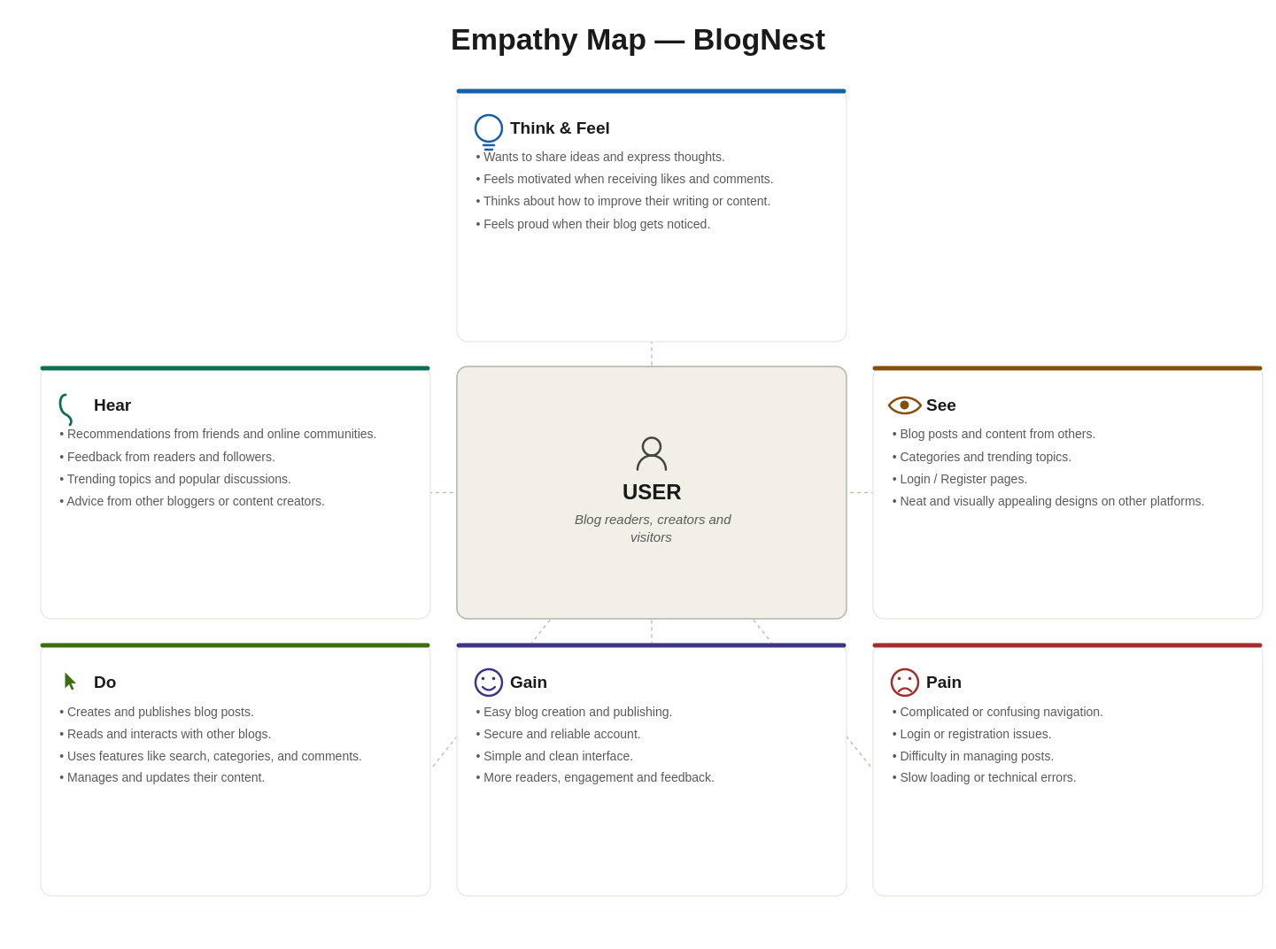
Example:
